Control Statement & Loop

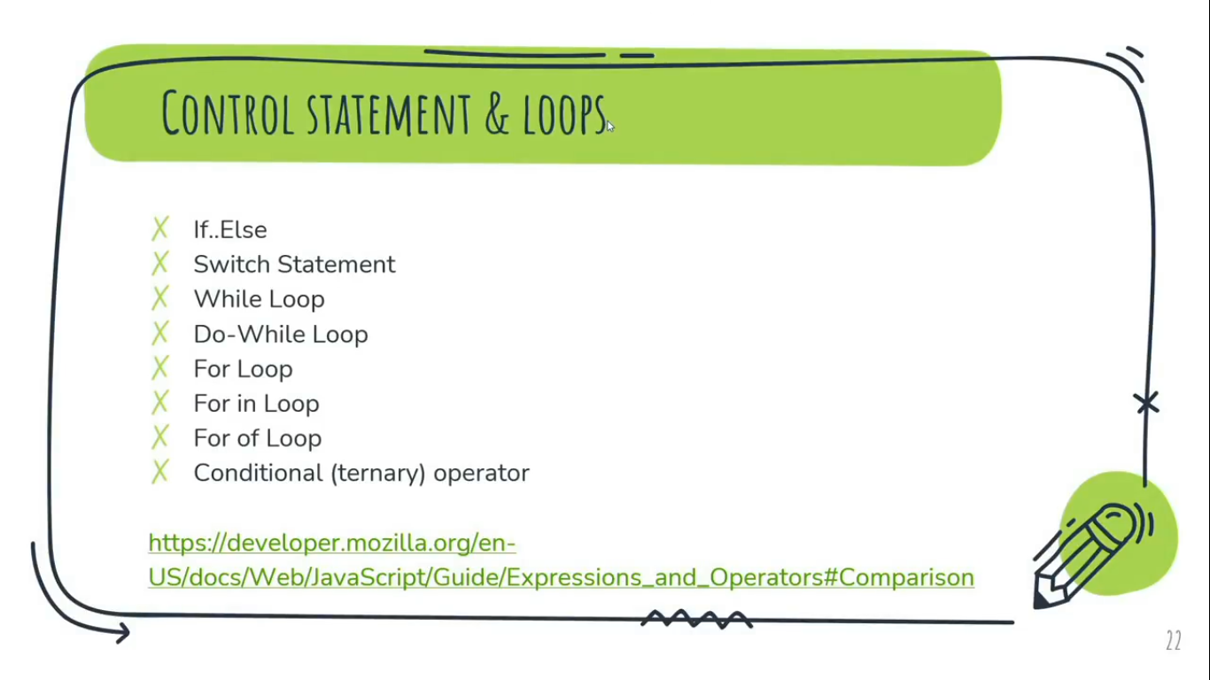  
For more Info: [https://developer.mozilla.org/en-US/docs/web/javascript/guide/expressions_and_operators#comparision](https://developer.mozilla.org/en-US/docs/web/javascript/guide/expressions_and_operators%23comparision)

**\*** What is truthy and falsy values in JavaScript?  
🡪 We have total 5 falsy values in JavaScript:  
0, “”, undefined, null, NaN, false  
After putting any of these 5 falsy values under the condition of JS, it will always execute else statement as false.   
Falsy means ‘false’ in JavaScript.  
  
On the other hand, if we put any values except the above 5 falsy value under the condition of JS, it will always execute the if statement as true by default and it will be consider as truthy values. Ex: 1000, 12423 etc.

**Note:**

* “” & “ ” both are different but same typeof ‘string’ data Type . “” is falsy value in JS where “ ” is truthy value in JS.
* False keyword always consider as falsy value whereas true keyword always consider as truthy value.
* Only **0** always consider as falsy and rest of all the numbers (Including **1**, -1, 2, 100, etc..) are always consider as truthy.
* In If else conditional statement. If the condition given in If statement is falsy, then it will always jump to the else statement and execute it.  
  In if else conditional statement. If the condition given in if statement is truthy, then it will always execute the If statement.  
  **Ex-1:**If(0) ***//*** ***0 is falsy***  
   console.log(‘this is falsy’);  
  else  
   console.log(‘this is truthy’);  
  **Output:**  
  this is truthy  
    
  **Ex-2:**If(!0) ***//*** **!*0 is truthy***  
   console.log(‘this is opposite of falsy’);  
  else  
   console.log(‘this is truthy’);  
  **Output:**  
  this is opposite of falsy

Conditional (ternary) operator:

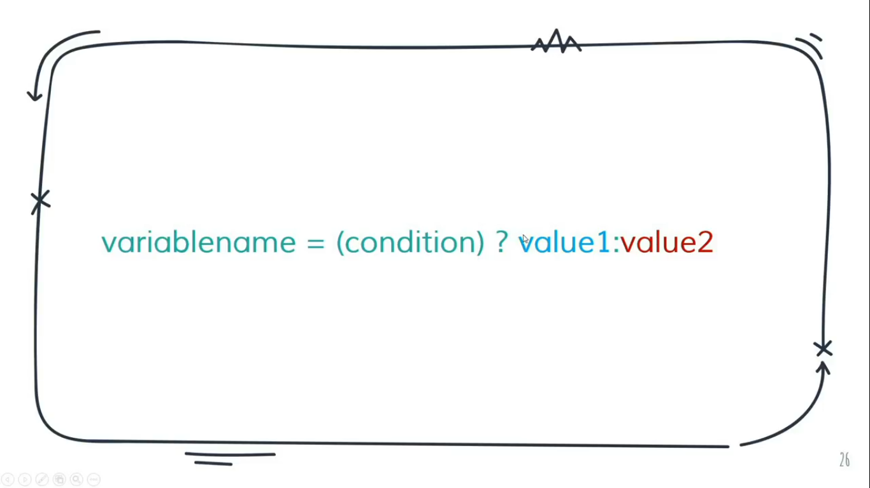

The conditional (ternary) operator is the only JavaScript operator that takes three operands.  
We use conditional operator to write single ‘if else’ condition in sort.

**Switch Statement:**

It Evaluates an expression, matching the expression’s value to a case clause, and executes statements associated with that case.

We use switch statement to write nested ‘if else’ condition in sort manner.

**Note:**

**Break** – It terminates the current loop, switch, or label statement and transfers program control to the statement following the terminated statement.

Switch statement work with same type of condition with nested if else.

**While Loop:**

The while statement creates a loop that executes a specified statement as long as the test condition evaluates to true.  
Example:  
var num = 0;  
while(num <= 10)  
{ // Block Scope start  
console.log(num);  
num++;  
} // Block Scope end

**Note:**

Do while loop can execute at least one time even the condition is false but statement of while loop only start execution after under the condition is true.

**For Loop:**

